**Position vs. Time Packet**

**Type of Motion** **P-T Sketch** **Motion Map**

1)__________________



2)__________________



3)__________________



4)__________________



5)__________________



6)__________________



7)__________________

**How would you walk to create each of these Position Time Graphs?**

**Note: Each dot separates different regions of motion.**

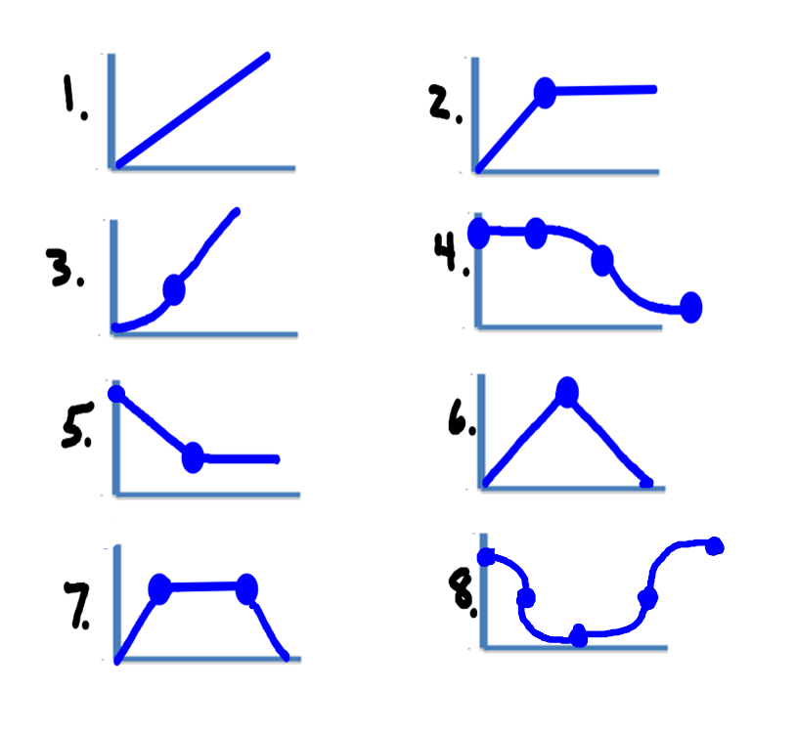

**P-T Racing Questions**

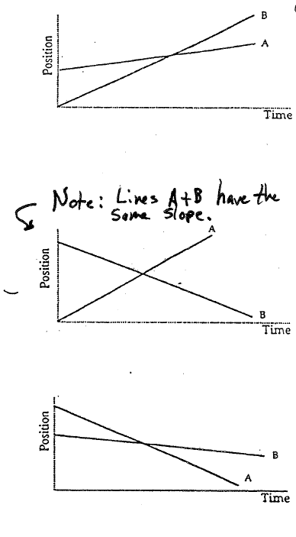

1. Which object is moving faster, A or B?

2. Which object gets a headstart?

3. What is happening in this race when the lines cross?

4. If I asked you “Which object is faster?” it would be a trick question. Explain why this is a trick question.

5. Which object has a negative velocity?

6. Which object is moving faster?

7. Which object gets a headstart in this race?

**For this Position Time Graph…**

1. Fill in the type of motion (Still, Constant Velocity, Speed Up, Slow Down), the direction (Away or Towards), and the speed for each region.

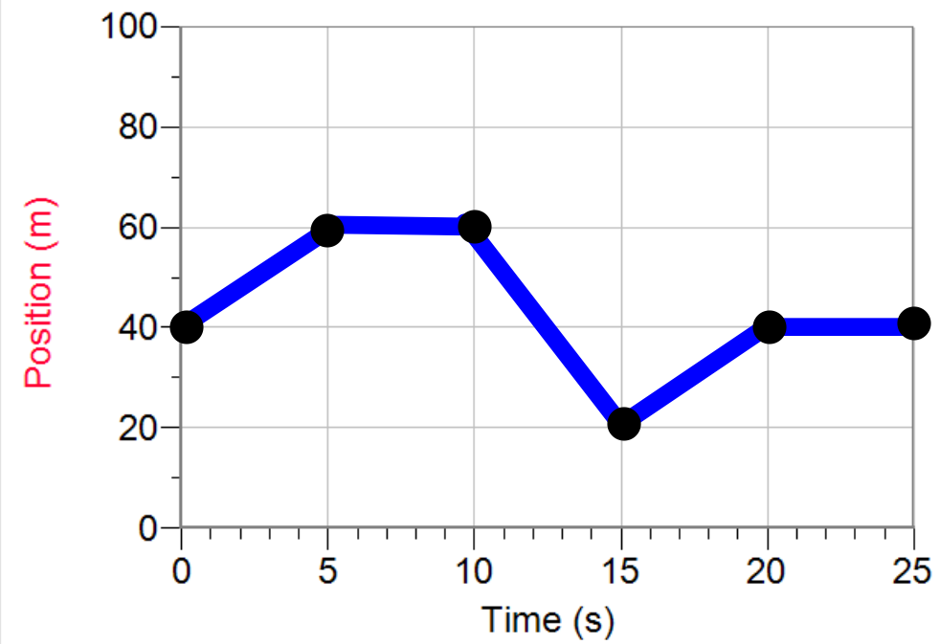

|  |  |  |  |
| --- | --- | --- | --- |
| **Region** | **Type of Motion** | **Direction** | **Velocity (m/s)** |
| 0 to 5 s |  |  |  |
| 5 to 10 s |  |  |  |
| 10 to 15 s |  |  |  |
| 15 to 20 s |  |  |  |
| 20 to 25 s |  |  |  |

2. In which region is the object moving the fastest?

3. What is the total distance the object covers for its trip?

4. What is the displacement of the object for the entire trip?

**For these questions, list all graphs that apply.**

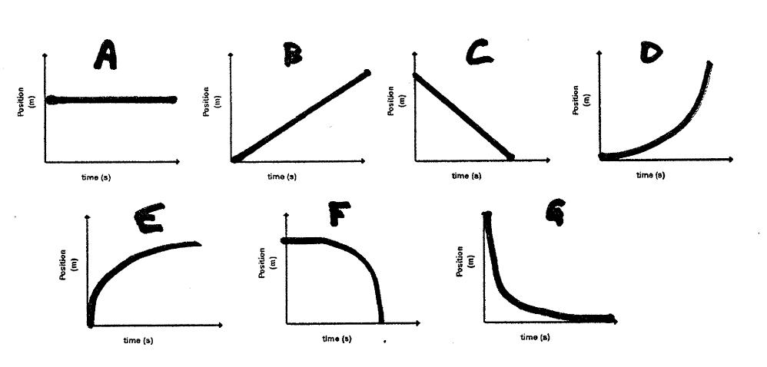

1. Which graph(s) represent a constant velocity? __________________

2. Which graph(s) represent a changing velocity? __________________

3. Which graph(s) show an object that is speeding up? __________________

4. Which graph(s) show an object that is slowing down? __________________

5. Which graph(s) contain a positive slope? __________________

6. Which graph(s) contain a negative slope? __________________

7. Which objects are still? __________________

8. Which graph(s) start at the origin? __________________

9. Which graph(s) start somewhere other than the origin? __________________

10. Which graph(s) show motion away from the origin? __________________

11. Which graph(s) show motion toward the origin? __________________

12. Which graph(s) show positive displacement? __________________

13. Which graph(s) show negative displacement? __________________

14. Which graph(s) show zero displacement? __________________

**Position Time Graph Regions Practice**

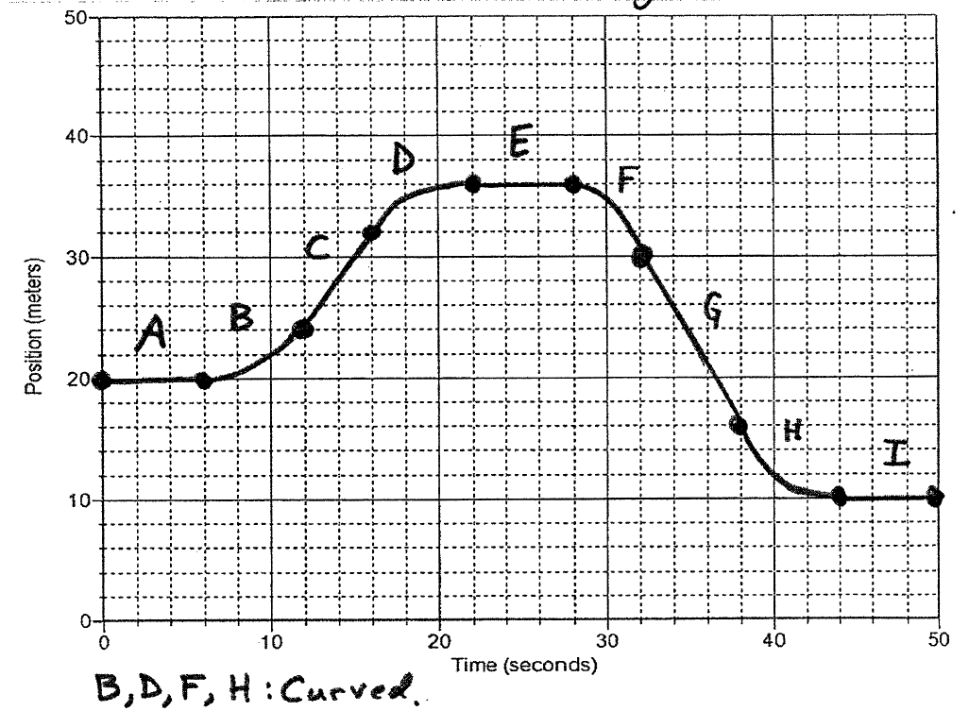15. Label each region by type of motion (Still, CV-Away, Speed Up Away, etc).

16. In which region(s) is the object not moving? _______________

17. In which region(s) is the object moving at a CV? _______________

18. In which region is the object the closest distance to the origin? _______________

19. In which region is the object farthest away from the origin? _______________

20. How can you calculate velocity from a PT graph? _______________

21. What is the displacement of the object in the above graph? _______________

22. Is it possible to slow down after you have stopped? _______________

**Drawing PT Graphs**

* *Draw each of these graphs on the provided axes.*
* *Use a dot to separate each region (helps you get partial credit)* 😊

1. CV Away, then CV Towards.

2. Slow constant speed away, then faster constant speed away.

3. Object is at rest.

4. Constant speed towards, stop then speed up away.

5. Speeding up away, then slowing down away.

6. Speeding up away from rest to a fast CV away.

7. A driver is moving at CV, he hits a squirrel, stops, then reverses at CV, then stops to see if the squirrel is OK.

8. One car following at a fixed distance behind a second car, both are moving at the same CV (show both cars on the same graph.)

9. Leaving home (slowly) to go to the dentist, sitting in the dentist chair for a while, then rushing back home to watch Ellen.

10. A turtle moving at CV gets a head start on a rabbit in a footrace. The rabbit passes the turtle after a few seconds.

11. Police car catching up to, pulling over, and stopping behind a speeding car (draw both cars on the same graph.)

12. Make up your own multi-stage situation and draw its graph.

